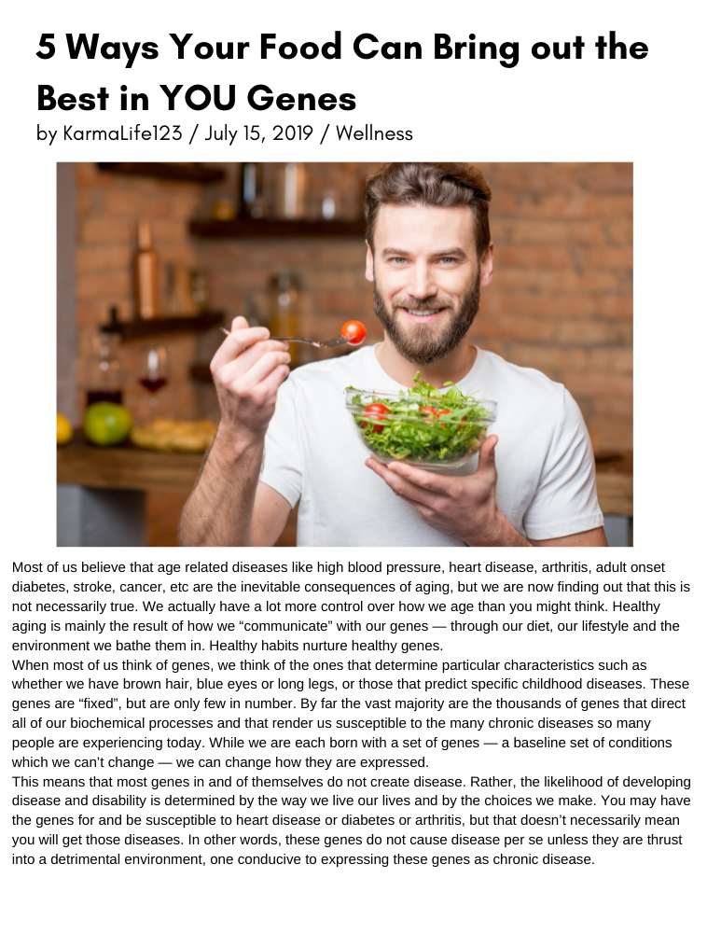

There are multiple factors in your diet, environment and lifestyle that affect your genes and how you age. Many of these are within your control. Of all the factors, diet is the easiest to control and probably the most important determinant of how our genes are expressed. A revolutionary new science, Nutrigenomics, is showing how different foods may interact with specific genes, how food “talks” to our genes and how our genes express themselves after the conversation. It is confirming that food provides potent dietary signals that directly influence the metabolic programming of our cells and modify the risk of common chronic diseases. It is telling us that food is information, that it contains “instructions” which are communicated directly to our genes. Armed with this information, your genes commandeer various metabolic actions and affect millions of critical biological processes, including cholesterol levels, aging, hormone regulation, weight gain and loss, and much more. Eat the right foods and they will send instructions to your genes for good health. Eating the wrong foods however, sends messages for disease. What we are finding out is that there is so much more to food than just the nutrients we have discovered thus far. Real food is packed with thousands of compounds which have a complex and dynamic relationship with one another and your genes. With processed foods however, these micronutrients have either been altered or are missing, and therefore they can never deliver the same beneficial messages to your genes. Just as a computer program won’t function well when it gets fed bad data, neither will your body. Once you understand that food is “data” or complex information that the body uses to direct the multifaceted actions that keep us vibrantly alive, it’s easy to understand that loading up on junk food is like taking the fast lane to a giant system failure. Foods loaded with sugar, trans fats and chemicals, and foods processed beyond recognition, are simply “bad data” for human consumption. I call these “food-like substances” because they are not real food. If you eat these regularly, your body stops working properly. It makes perfect sense, when you think about it. When you bathe your genes in an unhealthy environment, like the one created when you eat junk food, your genes “miscue” metabolic actions that can trigger disease. For example your body responds to “food-like substances” as if they are “foreign bodies”. This prompts an inflammatory response as your body tries to protect itself. Over time, continued consumption can lead to the development of a low grade chronic inflammatory condition which is now becoming recognized as an important precursor to a variety of more serious forms of illness. Bottom line: the food you eat affects the functioning of your genes. Here are 5 ways to improve the “conversation”. 1) Eat real food i.e. fresh, whole, unrefined and unprocessed food. Food is more than a delivery system for nutrients containing protein, fat, carbohydrates, vitamins, minerals and phytonutrients. Real food is more than the sum of its parts, it’s about how it all works together, about the integrity of the information or the total message. Although you should know how to read food labels, most real food does not come with a label …vegetables, fruits, nuts, seeds, grass fed meats, wild fish, organic chicken and eggs etc. 2) Although there is no one right diet for everyone (as we are all different), try eat as close to nature as possible because the further removed food is from its source the less good data it will contain, and the more likely it is of being a “food-like substance” and not real food. 3) Be careful of obsessive calorie counting. Figuring your diet simply in terms of calories or even percentages of protein, fat and carbohydrate, can inadvertently deprive your body of the “complete” messages that real, whole foods provide . 4) Stop eating when you are 80% full. 5) Don’t waste your time feeling guilty if you ate the “wrong” thing. Source: Ways food can bring out the best in your genes

